ContentGen – AI-Powered Blog Content Generation System

Description
The ContentGen backend is a secure and intelligent REST API platform designed to simplify blog creation, content management, and AI-assisted writing. Developed using Node.js and Express.js, the application uses MongoDB as its primary database, with Mongoose ODM for efficient data modeling, validation, and database operations.
The platform integrates AI-based functionalities such as AI-powered blog generation and intelligent content summarization, enabling users to generate structured blog posts and concise summaries with minimal effort.
The system implements JWT-based authentication, role-based access control (Admin, Editor, Author, Reader), and secure password hashing to manage user permissions and protect user information. It also supports blog management, categories, tags, comment management, media handling, and advanced content retrieval.
Designed with a structured MVC architecture, ContentGen separates models, controllers, and routing functionalities to maintain organized backend operations and improve code management.

Scenario-Based Case Study

Background

Priya is a content creator who manages multiple blogs but faces difficulties in organizing posts, scheduling publications, managing categories and tags, and tracking reader engagement efficiently.

Problem

    - Difficulty managing multiple drafts, categories, and tags.
    - Limited visibility into post performance and engagement analytics.
    - Time-consuming content approval and comment moderation.
    - No streamlined system for handling media uploads and metadata.
    - Lack of collaborative permission levels for editors, authors, and administrators.

Solution

The ContentGen backend provides a centralized and secure API system that manages blog-related operations. It separates application logic from frontend delivery systems and introduces role-based permissions for content management, publishing workflows, category organization, and user management.

Usage

Author Usage: Authors can create blog posts, manage drafts, organize content, and review their post-performance information.
Editor/Admin Usage: Editors and administrators can review pending posts, update publishing statuses, moderate comments, and manage user permissions.
Reader Usage: Readers can access published blogs and submit comments through the available API endpoints.

Outcome

By implementing a centralized backend system, ContentGen simplifies blog management and reduces manual content-handling activities. Data validation maintains database consistency, while role-based access control ensures that users perform only their permitted operations.

Software Requirements
The following software components are required to develop and execute the ContentGen application.

Software | Description
Windows 10/11, macOS, Linux | Operating system
Node.js (v16 or above) | Runtime environment
npm (v8 or above) | Package management

Express.js | Backend web framework
MongoDB | Database management
Postman | API testing
Visual Studio Code | Code development environment

Hardware Requirements
The hardware requirements for running the ContentGen backend are:

- Processor: Intel Core i5 (8th Gen or above) / AMD Ryzen 5 or equivalent.
- RAM: Minimum 8 GB, with 16 GB recommended.
- Storage: 1 GB of available disk space.

Project Architecture
The ContentGen application follows a structured backend architecture where incoming API requests pass through different processing layers before interacting with the database.

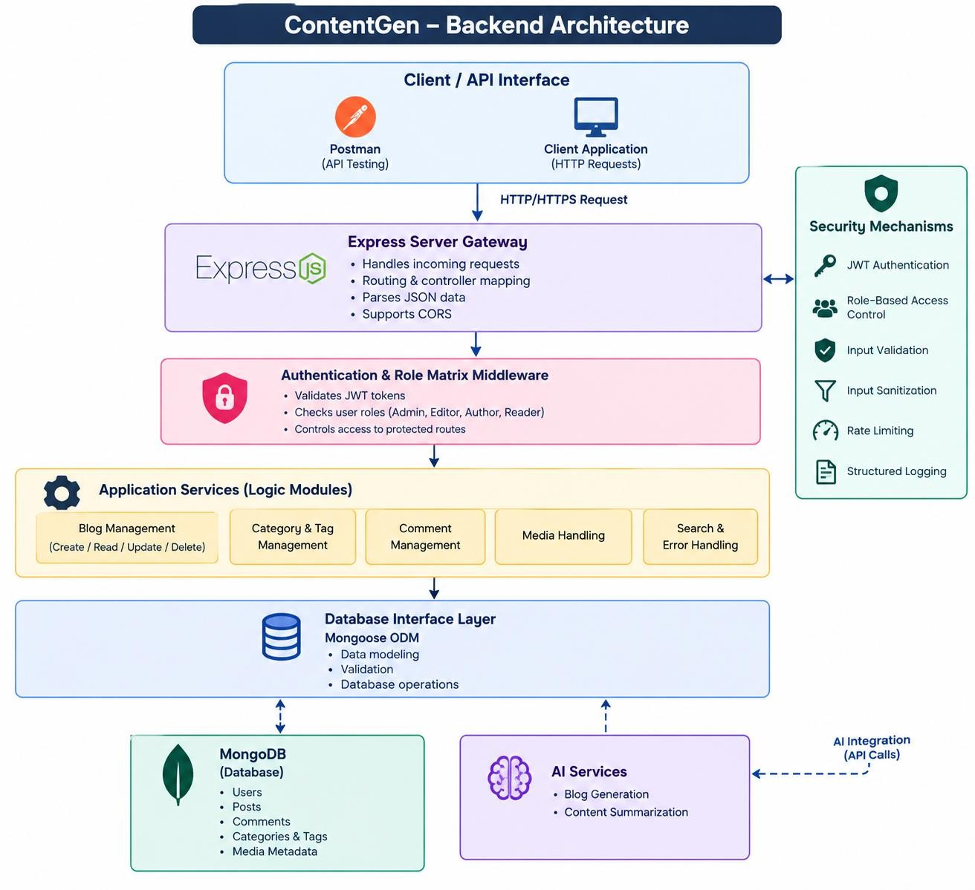
- Client / API Interface: Allows users to interact with the application through HTTP requests using Postman or a client application.
- Express Server Gateway: Receives requests, routes them to appropriate controllers, and handles JSON data.
- Authentication & Role Middleware: Verifies JWT tokens and checks user roles like Admin, Editor, Author, and Reader.
- Application Services: Handles the main functionalities such as blog management, category management, comments, media handling, and search.

- Database Interface Layer: Uses Mongoose ODM to validate data and communicate with MongoDB.
- MongoDB Database: Stores user details, blog posts, comments, categories, tags, and media information.
- AI Services: Provides automatic blog generation and content summarization.

- Security Mechanisms: Protects the application using JWT authentication, role-based access, input validation, sanitization, rate limiting, and structured logging.

Entity-Relationship (ER) Diagram Description
The database structure of ContentGen consists of different entities that maintain relationships between users, posts, and comments.

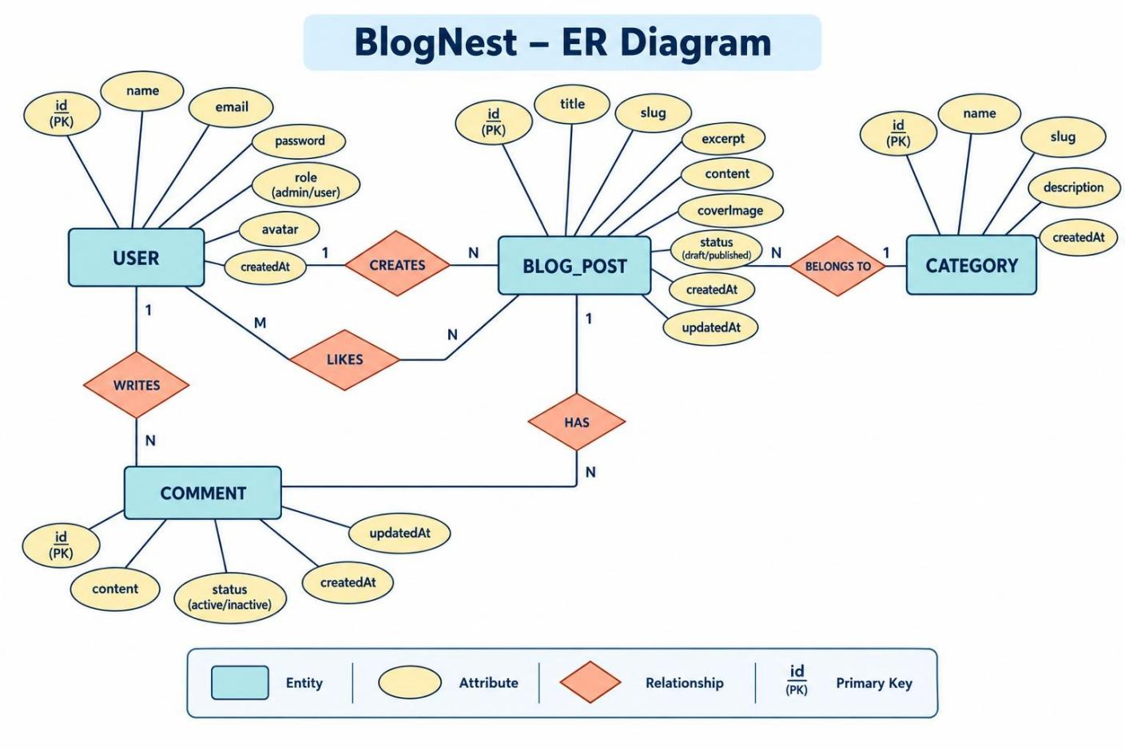

User Entity

  - _id (Primary Key - ObjectId)
  - name (String, Required)
  - email (String, Required, Unique)
  - password (String, Hashed, Required)
  - role (String, Default: "reader")

Post Entity

  - _id (Primary Key - ObjectId)
  - userID (Foreign Key referencing User Collection)
  - name (String, Required - represents Title)
  - photo (Object/String - Image file path or URL)
  - message (String - Core content body)
  - likes (Number, Default: 0)
  - timestamps (True)

Key Structural Mappings
  - User to Post (One-to-Many): A single author can create and manage multiple blog posts within the application.
  - User to Comment (One-to-Many): Individual users can submit multiple comments across different blog posts.
  - Post to Comment (One-to-Many): Each blog post can contain multiple associated comments submitted by different users.

Key Features
  - Role-Based Access Control: Implements authentication and authorization mechanisms to restrict unauthorized users from accessing protected application functionalities.
  - CRUD Blog Management: Supports complete Create, Read, Update, and Delete operations for managing blog posts and their associated content.
  - Category Management System: Organizes blog posts using categories and tags to improve content classification, filtering, and accessibility.
  - Comment Management System: Provides controlled comment operations, including adding, editing, deleting, and managing comment approval statuses.

  - Input Validation and Security: Implements data validation and sanitization techniques to prevent security vulnerabilities such as XSS attacks and NoSQL injection.
  - AI-Based Blog Generation System: Integrates external Large Language Model (LLM) services and structured prompt templates to generate detailed blog content from user-provided topics.
  - Automated Content Summarization: Utilizes AI-based summarization techniques to process lengthy blog articles and generate concise summaries for improved readability and content accessibility.

Roles and Responsibilities
  - Admin: Has complete system management privileges. Responsible for managing user accounts, assigning roles, controlling application settings, monitoring activities, and removing inappropriate comments.
  - Editor: Responsible for managing editorial activities, reviewing submitted blog posts, approving content for publication, and maintaining category information.
  - Author: Has permission to create and manage their own blog posts. Can access and modify only the content associated with their account.
  - Reader: Can access and read published blog posts, explore available content, and submit comments using their authenticated account.

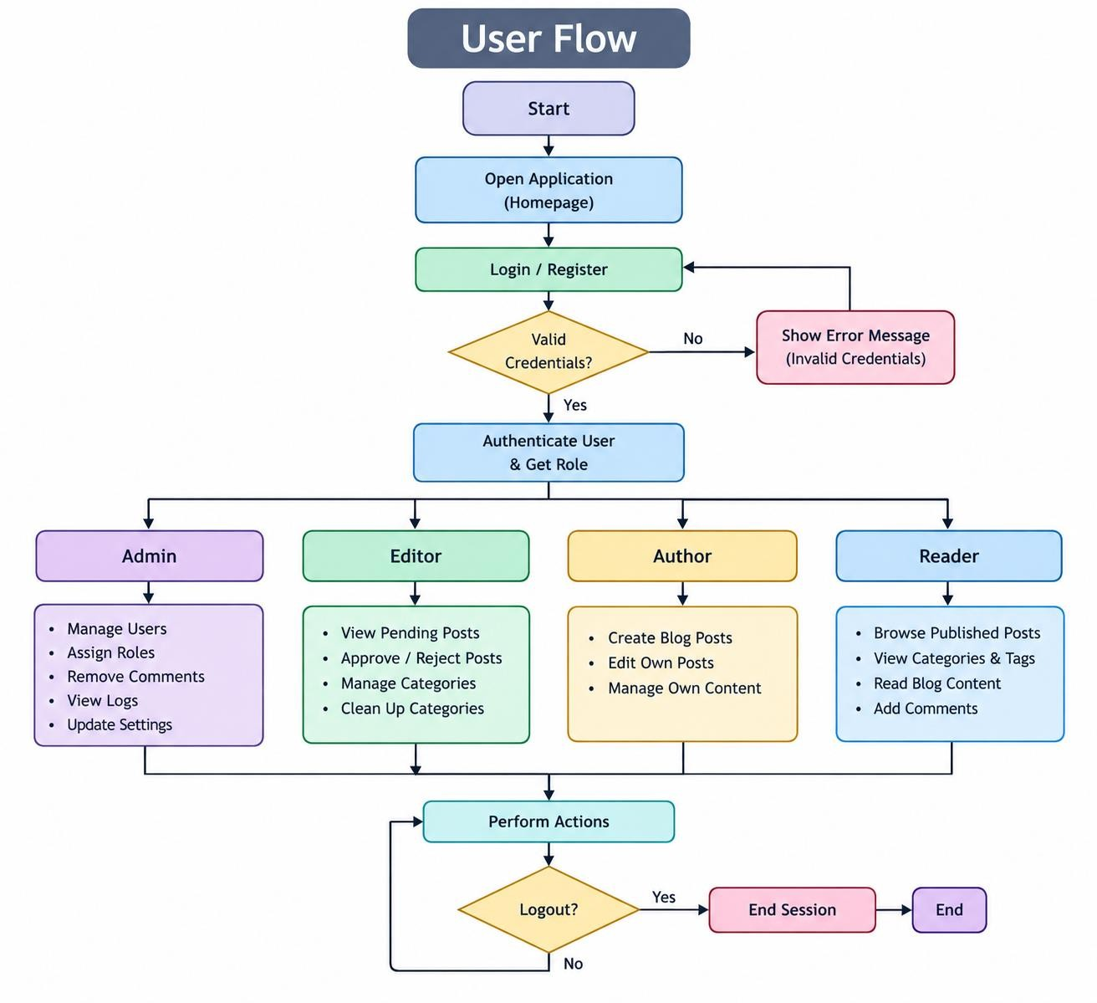

MVC Architecture Pattern
The ContentGen application follows the Model-View-Controller (MVC) architectural pattern, which organizes the application into separate functional layers. This approach ensures proper separation of concerns, improves code maintainability, and enables efficient communication between different components of the system.

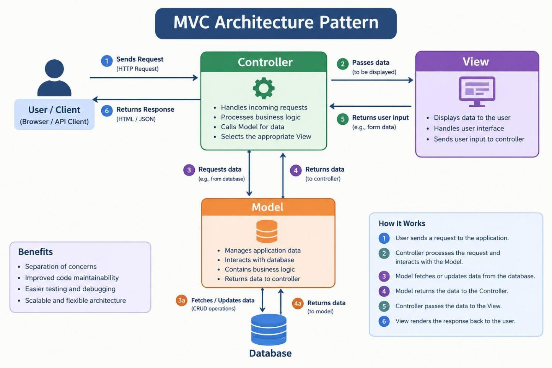

Model Layer (Data Management Structure)

Defines the application's data structure through Mongoose schemas, mapping specific fields and attributes into MongoDB collections. It establishes validation rules, default values, indexing configurations, and data transformation mechanisms before storing records in the database.

Controller Layer (Request Processing Engine)

Acts as the central processing component of the application. It receives incoming requests from the routing layer, validates request parameters, executes business logic, communicates with the Model layer for database operations, and returns the processed results through standardized JSON responses.

View Layer (API Interface Layer)

In this backend-focused application, traditional frontend view templates are not directly implemented. Instead, the interface is handled through the API Routing Layer, which maps incoming HTTP requests to their corresponding controller functions. It enables seamless

communication between the client application and backend services through structured API endpoints.

Epic2: Project Setup and Configuration

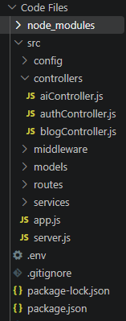

Epic 3: Backend Development

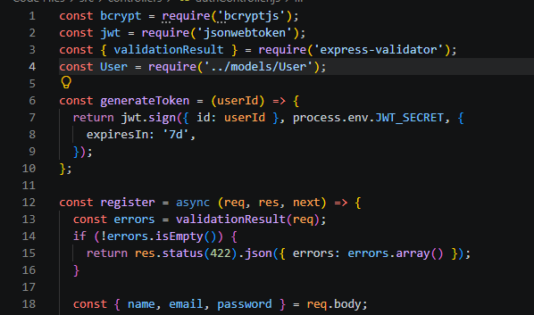

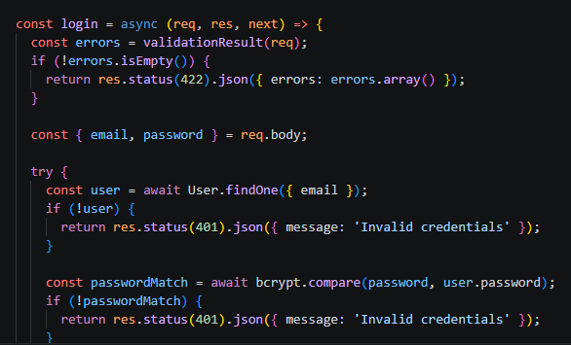

Epic4: Database Configuration

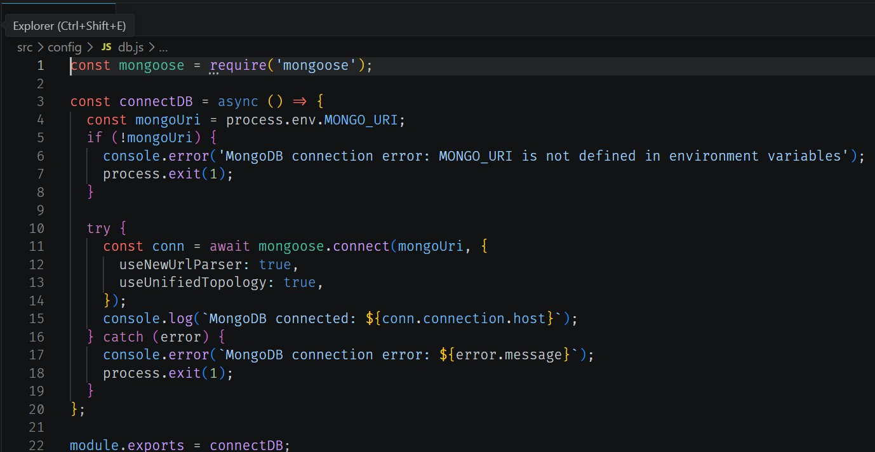

Configure MongoDB:

  - Install Mongoose.
In your Node.js project directory, run:
npm install mongoose
  - Create database connection.
  - Create Schemas & Models.

Create Database connection:
Now, make sure the database is connected before performing any of the actions through the backend. The connection code looks similar to the one provided below

Mongoose Schema Definitions

1. Identity Resource Document Schema (schemas/userModel.js)
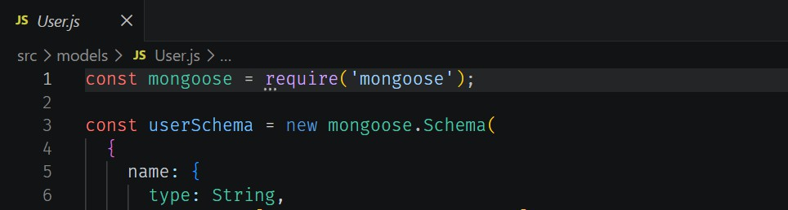
Enforces field criteria validations on incoming database creations:

Epic 5: Project Executions:

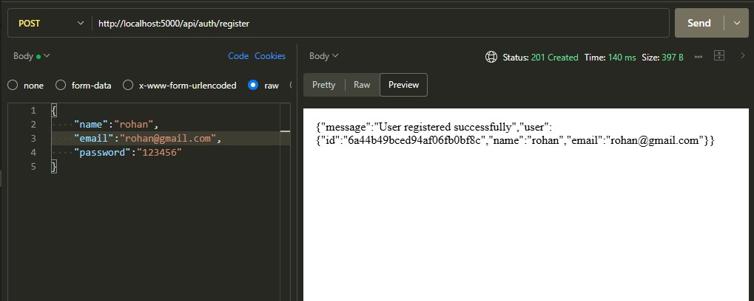
User Registration
User Login:

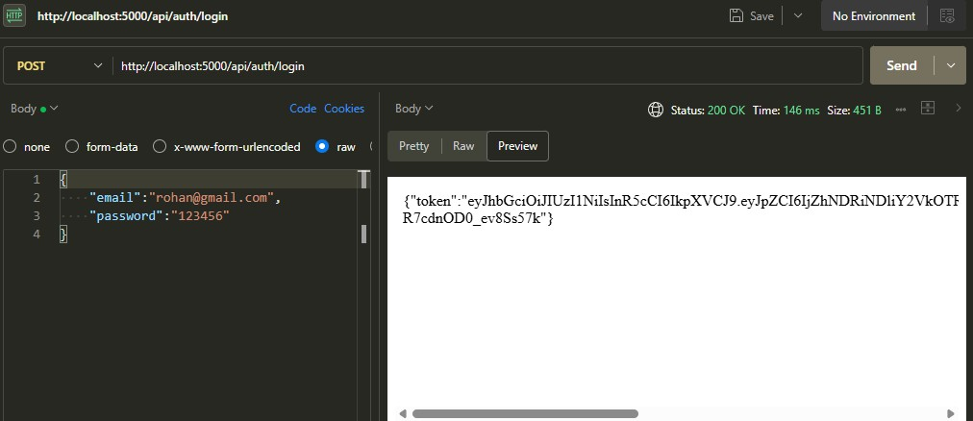

Create Blogs :

Fetch Blogs : 

Generate AI blogs :

Summarize Blogs :

API TESTING VIDEO LINK- https://drive.google.com/file/d/1Yh17MOPSwWGdKIIjexA1nSbQjbiYmyTs/view?usp=drive_link
DEMO VIDEO LINK- https://drive.google.com/file/d/1-YLaS4DSLLoBqMRUz4CymFqLLJ4bTTNU/view?usp=drive_link

CODE DRIVE LINK-

